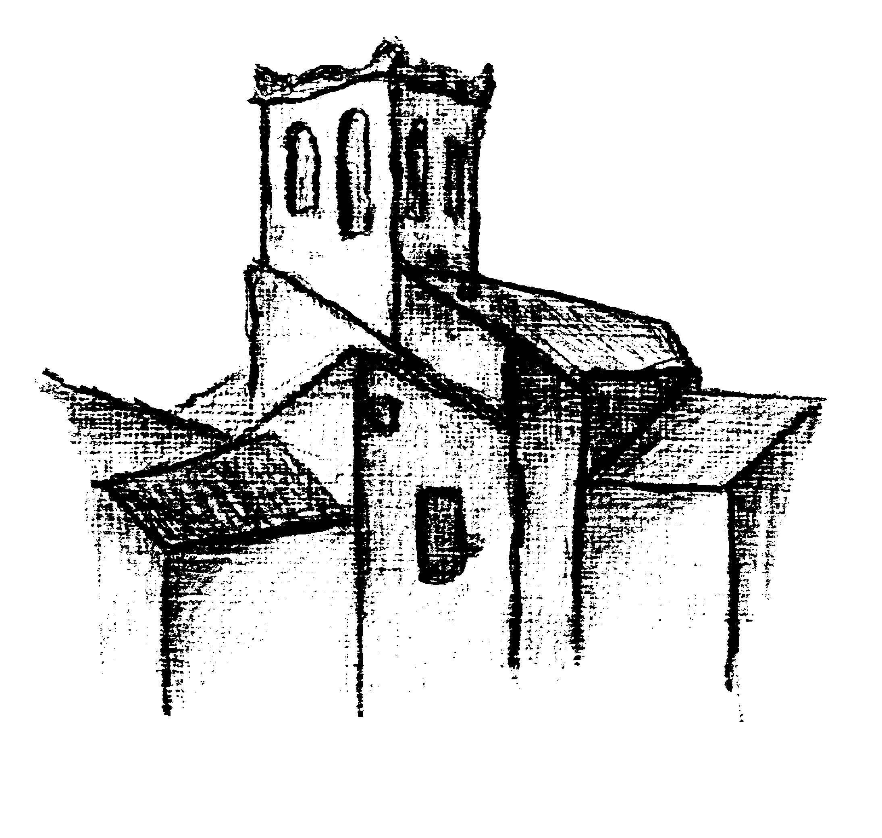
Весало - тур

 | Международный фестиваль-конкурс  театров моды, искусства костюма и  художественного творчества  «Краски Сахары»  International festival-contest of the fashion theatres, dress designers and creative art «Kraski Sakhari» («Colours of Sakhara»)

1. GENERAL REGULATIONS
THE REPRESENTATIVE OF CHILDREN’S AND YOUTH INTERNATIONAL
FESTIVALS IN THE RUSSIAN FEDERATION “VESALO-TOUR”
INVITE TO PARTICIPATE IN THE INTERNATIONAL FESTIVAL-CONTEST OF THE FASHION THEATRES, DRESS DESIGNERS AND CREATIVE ART “KRASKI SAKHARI” (“COLOURS OF SAKHARA”)

1.1. The Festival-contest program consists of 5 days.
Estimated period: 27 April - 7 May 2015 г.
Individual terms of arrival shall be discussed additionally.
1.2. Place of holding: Tunisia, Hammamet
1.3. The Festival-contest is held with support of Tunisian Ministry of Culture, Tunisian Ministry of Tourism, Tunisian National tourist office and Russian magazine «Technology Festival».

- RULES
2.1. Participants of the festival-contest
2.1.1. Fashion studios, model agencies, fashion theatres, fashion designers etc.
2.1.2. Ensembles, duets, soloists of different nominations (sections) – choreography, vocal, instrumental etc.
2.2. Creative collectives and single persons (soloists) beyond 3 years old can participate in the contest.
2.3. Genre «Fashion art» is basic for the festival-contest.
2.4. Complementary genres of the Festival-contest are «Choreography art», «Singing art»; «Instrumental music», «Circus art»; «Fine and creative art», «Drama theatre», «Music theatre», «Original genre» etc.
2.5. Two nominations are determined for the genre «Fashion art»:
а) «Group show of collection». Collections shall be presented in different art styles or themes: «Casual fashion», «Avant-garde fashion», «New fashion materials», «Batik», «Evening fashion», «Sport fashion», «Historical costume» etc.
б) «Individual show of a single author's costume». The participant aged from 14 years shows the costume, made according with the author's project independently or with an instructor.
«Oriental» collections or costume are welcomed!
2.6. The collections consisting not less, than 3 models are accepted. Stylized show of children clothes is acceptable – up to 10 minutes. In nomination «Group show of collection» the participants should show 2 collections.
2.7. In competitive work any auxiliary materials and accessories can be used. Different kinds of processing of a decor are accepted. The collection should be complete, any use of style directions and the fashion trends, new technologies in processing of materials, nontraditional application of known materials, search of new perfect forms and constructive decisions in the field of design of a costume are accepted.
On each collection or an individual costume the summary (3-5 sentences), opening the sense and idea according to the chosen nomination is represented.
2.8. The priority of performances is defined by the program. During the demonstration of collection the stage adaptation and the musical design, strengthening the effect of performed work, opening the advantage of a creative plan and skill of young fashion designers are possible.
2.9. Demands towards participants of the festival-contest. The complementary genres.
Choreography (people dance (folk); classical dance; modern dance). Participants in solo and small forms compete in their nominations and are not divided into age groups.
Age categories: junior group – 7-10 years; medium group – 11-14 years, senior group – 15 years and above. Two numbers shall be presented at the contest. General term of a presentation up to 8 minutes.
Vocal (variety song (pop, jazz etc.); people song (traditional); academic genre (classical); folk-lore collectives). Age categories: A category 1 – 5-8 years; a category 2 – 9-12 years; a category 3 – 13-15 years; a category 4 – 16 years and above. 2 songs sung to a phonogram (minus) shall be presented at the contest, a-capello, separate accompaniment. A phonogram shall be presented at CD-R or (USB) flash drive (flash memory card). A phonogram (plus) shall be available. Duration of each song – up to 4 minutes.
In nominations – people and academic vocal presentations with “natural” accompaniment are welcomed.
Instrumental music. Up to 30 % of adults are acceptable in a group (orchestra). 2 numbers are presented, up to 5 minutes duration each.
Show-programs: Original genre – circus and sport programs. The program will have to present up to 10-15 minutes.
Fine and creative arts (painting, drawing, small plastic art, domestic craft). Each participant may present up to 2 works. One paint is accepted as homework for the painters, the theme «Along the waves». Another work will have to paint at open air practice.
2.10. It is obligatory that teachers bring 2 different copies of each CD-R in the event of malfunction of the original. Only the song for that entry may be on the CD-R. It should be cued and clearly marked with the name of the song and studio/soloist. CDs must be turned in at least one hour before the scheduled time and performance time.
A phonogram shall be presented at CD-R or (USB) flash drive (flash memory card).
All copyright negotiations are the responsibility of the participant.
2.11. Props are allowed but must be “free standing”. Any litters on stage after your performance must be clean by your crew. Any unnecessary delay will result in a point deduction. Smoking is prohibited in all competition and dressing room areas and limited to those areas designated by the facility. Food or drink is prohibited in the competition area or backstage. It is expected that all competitors and attendees will conduct themselves as ladies and gentlemen at all times.
2.12. Any artist in competition takes certain incumbent risks. These include, but are not limited to, sprains, pulled muscles and broken bones. Participation in this contest indicates the acceptance of such risks by performers. Direction and the hosting faculty are not responsible for personal injury or property loss at its events.
2.12. Technical settings (specification) are required for any performance. It have to send and submit to Executive management approval in advance.
We would like to draw your attention to the fact that all the participants are enabled to prepare a full concert program for the festival to organize a performance on the public stages of the host country!!!

3. ADJUDICATORS
3.1. The jury structure is formed by organizing committee of fashion artists, choreographers, stage directors and art workers of the different countries.
3.2. Judges value the performance of participants on 10 points system. The best participants are assigned on a total sum of points. Judges’ decisions are final: teachers, artists or/and parents are not permitted to discuss scoring or results with judges. While some judges may be involved in multiple performance categories, other will concentrate in the specialties only.
After the competition score sheets can be distributed to teachers only.
3.3. The Festival-contest program can be filled with master-classes and/or with a leading a round-table discussion.

- CANONS OF CRITICISM
4.1. The competitive performances of a genre «Fashion art» are valued by such criteria as: unconditional conformity to the general collection theme and to the collection theme chosen by participant; an idea actuality, a design, an ensemble and figurativeness in disclosure of a theme; a know-how (innovation, the creative approach in application of materials and technological decisions); a staginess, a theatricality (stage direction, musical and artistic realization of a plan); a degree of quality and of skill of competitive work; a draft realization of creative work, a fashion parade.

4.2. The Adjudicator will give credit for the quality of the performance, purity of the intonation, level of technical and artistic interpretation of the music composition, the choice of the program, musicianship, creativity, stage presence, costumes etc.
5. PRIZES AND TROPHIES, PLACINGS
5.1. The Grand Prix of the festival-contest is CUP and Prize Bounty Grant. Judges award with 1st place, 2nd place and 3rd place in each genre. All participants are awarded with a certificate. Additionally participants are awarded with gifts.
5.2. The Special diplomas: «Fashion innovations», «Best model», «Best director», «Best theatre performance»
Judges reserved the right not to give all the awards.
Winners of the Festival-contest can be sent to children’s and youth international Festivals in Moscow.

- SCHEDULE
1 DAY: Opening Ceremony of the festival-contest «Kraski Sakhari» («Colours of Sakhara»);
2 DAY: Theatrical activities; Competition Show.
3 DAY: Competition Show. Semi-final;
4 DAY: Festival Show;
5 DAY: Gala Show and following Awarding Ceremony.
All theatrical, dates and location are subject to change.
We reserved the right to change the schedule, and we expect participants to be available to perform at anytime throughout the Festival-contest time.
The confirmation package and schedule of events will be mailed to each studio/independent entry within ten to twenty days of the competition.

- ORGANIZATIONAL MATTERS
To participate in the festival-contest it is necessary to send to the Executive management by e-mail vesalo-tour@mail.ru before March 15, 2015 an application of the prescribed form (entry form) and pay a «Special fee for participation in the Festival-contest» (Staying in a hotel, TRPL or QUADRIPLE rooms, meal - all incl., transfer airport-hotel-airport)

Hotel 4*
DURATION | Without airplane tickets
7 nights/8 days | 410$
10 nights/11 days | 520$
14 nights/15 days | 665$

A contest fee (competition entry fee) without accommodation (2 nominations, 2 items each) for solo participants 80$, for duets and ensembles – 45$ per person, accompanying person – 40$ per person (except head).

Additional payments for rooms SINGLE (25$ day per person) or DOUBLE (10$ day per person) could be added to the basic fees.

We reserve the right to limit the amount of the entries to the amount of performance time available. We recommend sending entries in prior to the deadline date, because we cannot guarantee a space in our program even if they are postmarked prior to/by the deadline date. The deadline date – March 15th 2015.

All rules and regulations are subject to change without notice.

8. EXECUTIVE MANAGEMENT
www.vesalo-tour.ru
e-mail: vesalo-tour@mail.ru

